UX Case Study: Optimizing the Google Pay Mobile Payment Experience

A Comprehensive Analysis and High-Fidelity Redesign Proposal

Prepared by : Meet Darji
UI/UX Design Intern at CodeAlpha
College : G.H. Patel College of Engineering and Technology Batch : 20th May 2026 – 20th June 2026

Executive Summary & Overview

Google Pay (GPay) is one of the most widely used digital payment platforms, enabling users to perform secure and seamless financial transactions through a mobile-first experience. Built on the Unified Payments Interface (UPI) in India, Google Pay offers services such as money transfers, bill payments, mobile recharges, merchant payments, and rewards programs. With millions of active users, the platform has become a key player in the digital payments ecosystem by providing fast, reliable, and secure financial services.

This case study presents a comprehensive analysis of the current user experience within the Google Pay mobile application. It examines the platform's strengths, including its intuitive payment flow, strong security mechanisms, and seamless UPI integration, while identifying areas where the user experience can be improved, such as feature discoverability, information hierarchy, and promotional content management.

The primary objective of this study is to propose strategic design improvements that enhance usability, reduce user friction, and create a more streamlined digital payment experience. By utilizing modern UI/UX design principles and prototyping tools such as Figma, the redesigned interface aims to improve task efficiency, simplify navigation, and strengthen user confidence during financial transactions.

User Persona Definition

To effectively analyze the user journey and identify usability challenges within Google Pay, it is important to define a representative user persona. The following persona reflects a major segment of Google Pay's user base young, digitally active individuals who frequently rely on mobile payments for daily transactions and financial management..

Persona: The Digital-First Student

Demographics & Psychographics:
- Age: 18 - 25 years old
- Occupation: Undergraduate Engineering Student
- Technology Usage: Heavy smartphone user with high digital literacy.
- Behavior: Frequently uses Google Pay for peer-to-peer transfers, mobile recharges, bill payments, online shopping payments, and merchant transactions. Values speed, convenience, and security in financial applications..

Pain Points:
- Finds it difficult to locate frequently used features when promotional offers and additional services occupy significant screen space.
- Experiences confusion when navigating between multiple payment options, rewards, offers, and financial service sections
- Gets frustrated when transaction history becomes difficult to scan due to limited filtering and organization options.

Deep Dive: User Journey Mapping

The following journey map traces the steps of our persona using Google Pay to complete a common financial task, such as transferring money to a friend and paying a monthly utility bill.

Phase 1: Launch & Navigation

User Action: The user opens Google Pay with the intention of quickly sending money to a friend or accessing a frequently used payment service.

Emotional State: Focused, task-oriented, and expecting immediate access to core payment functions.

UX Friction Points: Promotional offers, rewards, cashback banners, and financial service advertisements compete for attention on the home screen.

Phase 2: Payment Initiation

User Action: The user selects a contact, merchant, or bank account and initiates a payment transaction.

UX Friction Points: Multiple payment pathways (contact payment, bank transfer, QR payment, self-transfer) can occasionally create navigation.

Important transaction details may be displayed alongside secondary information, reducing visual clarity.

Phase 3: Transaction Verification

User Action :Before completing the transaction, the user reviews recipient information, payment amount, and account details.
Emotional State Cautious and verification-focused to avoid sending money to the wrong recipient.

UX Friction Points:
  - Users must carefully verify recipient details because mistakes in digital payments can be difficult to reverse.
  - Transaction confirmation screens sometimes present multiple pieces of information simultaneously, increasing cognitive effort.

Phase 4: Transaction Completion & History Review

User Action : The user successfully completes the payment and later accesses transaction history to verify the payment status.

Emotional State : Relieved after successful payment and seeking reassurance that the transaction was completed correctly.

UX Friction Points
  - Transaction history can become crowded for users who perform frequent payments.
  - Searching for a specific transaction may require scrolling through numerous records.
  - Filtering options for transaction categories and payment types can be improved.
  - Important details such as payment purpose, merchant category, or recurring payments are not always immediately visib

Comprehensive Heuristic Evaluation

Applying Jakob Nielsen’s 10 Usability Heuristics to the Google Pay mobile application reveals several strengths and opportunities for improvement in the current user experience.

Strengths

- Flexibility and Efficiency of Use:
Google Pay enables users to complete transactions quickly through features such as saved bank accounts, QR code scanning, recent contacts, and UPI integration. Frequent users can perform payments within seconds, minimizing the number of steps required to complete common tasks.
- Match Between System and Real World:
The application uses familiar financial terminology such as Send Money, Pay Bills, Bank Transfer, and Transaction History, making navigation intuitive for users. The payment flow closely mirrors real-world financial activities, reducing the learning curve for new users..

Weaknesses

- Aesthetic and Minimalist Design (Failed):
As additional services, offers, rewards, and financial products have been integrated into the platform, the home screen has become increasingly crowded. Promotional content often competes with primary payment functions for user attention, increasing cognitive load.
- Consistency and Standards (Partially Failed)
Some financial services and promotional sections use different visual treatments and layouts, creating inconsistencies in the overall user experience.

Proposed UX/UI Interventions

To address the identified usability issues, three strategic design interventions are proposed. These improvements focus on simplifying navigation, strengthening visual hierarchy, and improving user efficiency while maintaining Google Pay’s rich feature set.

Improvement 1: Quick Pay Button

  - The Problem: Users frequently open Google Pay to perform quick transactions such as sending money to contacts, scanning QR codes, paying via UPI ID, or paying bills. Currently, these actions require navigating through multiple sections of the home screen, increasing interaction time and reducing efficiency for frequent users.

  - The Solution: Introduce a dedicated Quick Pay Button prominently on the home screen. This feature provides instant access to the most commonly used payment methods through a bottom-sheet menu.

Key Design Changes :

  - Add a large, visually prominent Quick Pay button on the homepage.
  - Provide one-tap access to:
    - Pay Contact
    - Scan QR Code
    - Pay UPI ID
    - Pay Bills
  - Display recent payment shortcuts within the Quick Pay menu.
  - Use clear icons and consistent spacing for better usability.

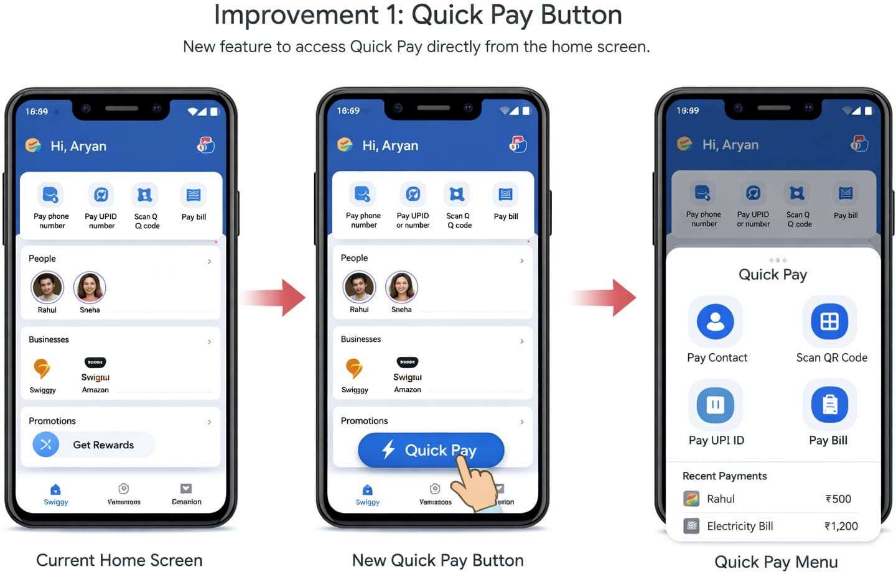

Expected Benefits :

  - Reduces the number of steps required to complete payments.
  - Improves efficiency for frequent users.
  - Minimizes navigation effort.
  - Enhances overall user satisfaction by providing faster access to core functions.

Improvement 2: Fraud Detection Alert

  - The Problem : Users may unknowingly transfer money to suspicious, fake, or recently created accounts. Existing verification indicators may not be sufficiently noticeable, increasing the risk of fraud and accidental payments.
  - The Solution : Implement a Fraud Detection Alert System that proactively warns users when suspicious activity or potentially risky accounts are detected.

Key Design Changes :
  - Display a high-visibility warning banner when risk is identified.
  - Mark suspicious recipients as Unverified Account.
  - Provide clear options such as:
- Learn More
- Report Fraud
- Cancel Transaction
- Proceed Anyway
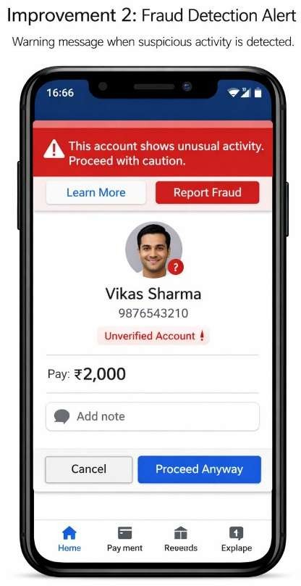

Improvement 3: Smart Identity Preview

  - The Problem : Many users accidentally transfer money to the wrong person due to similar names, incorrect mobile numbers, or mistaken QR-code scans. Current recipient information may not provide sufficient confidence before completing a transaction.

  - The Solution : Introduce a Smart Identity Preview system that displays recipient verification details before payment confirmation.

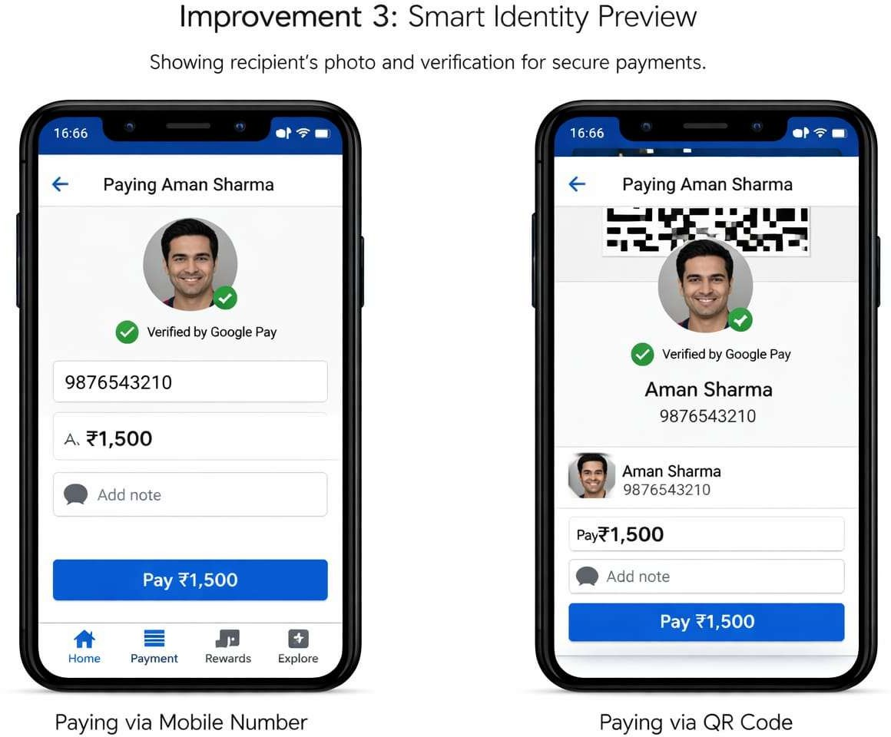

Conclusion

  - Google Pay's core strength lies in its fast, secure, and reliable digital payment ecosystem powered by UPI integration. The platform enables users to perform transactions, bill payments, and merchant payments with remarkable efficiency. However, as new features, promotional campaigns, rewards programs, and financial services have been added over time, the interface has become increasingly complex. To meet modern UX standards, Google Pay must continue evolving toward a cleaner, more intuitive, and user-centered experience.

  - The three proposed enhancements—Quick Pay Button, Fraud Detection Alert, and Smart Identity Preview—focus on improving the most critical stages of the payment journey. The Quick Pay Button reduces navigation effort and transaction time, the Fraud Detection Alert enhances security by warning users about suspicious accounts, and the Smart Identity Preview minimizes payment errors by providing clear recipient verification before transactions are completed. Together, these improvements address key usability, efficiency, and trust-related concerns identified during the user journey analysis.

  - By implementing these enhancements, Google Pay can further strengthen its position as a leading digital payment platform. The proposed solutions are practical, scalable, and aligned with modern UI/UX design principles.

